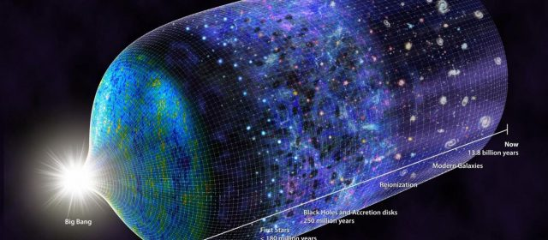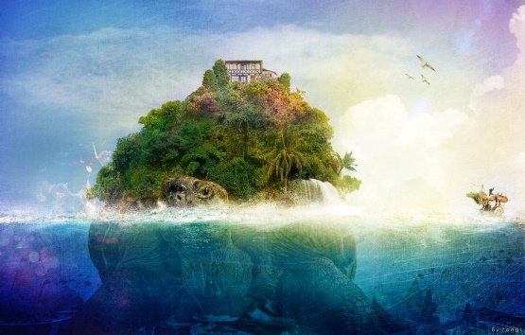

Project 1 – inventing your our cosmology

Project basics:
In this project, you need to invent your own cosmology. Be creative but keep it enclosed with as little self-contradiction as possible. Remember to make and include some illustrations.
You are welcome to draw ideas from different cultural and historical backgrounds. If you use quotes, please remember to include references. In addition, it will be very helpful if you use footnotes to provide comments on which sources did you base your ideas if any.

The Greek word cosmos is the universe literally. Using the word cosmos rather than the word universe implies viewing the universe as a complex and orderly system or entity, the opposite of chaos.
The cosmos, and our understanding of the reasons for its existence and significance, are studied in cosmology - a very broad discipline covering any scientific, religious, or philosophical contemplation of the cosmos and its nature, or reasons for existing.
So Cosmology is a set of knowledge and believes one has about the universe, how it was made, what makes it work and how and if it has an end.

Here is the suggested plan of creating your own universe and its history. Before you start, decide if your world has natural origin or a mystical/magical one; do you plan to have any supernatural figures such as deities – a pantheon or just one. Alternatively, just supernatural beings like Titans in Greek mythology. Is the scale the whole universe or just Earth and Solar system in one way or another?

Step 1: Genesis
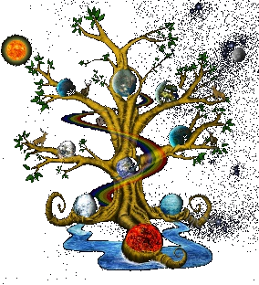
How did it all start? A rupture is vacuum creating Big Bang as we think now or a seed from an Yggdrasil tree? Best if none of the above – use your imagination (which can also create worlds…).
Be specific both on the scale – is universe infinite or finite? Are the stars other worlds or just holes in the celestial sphere, or milk drops in the skies? What forces hold your universe, what is the main law there?
What is the center of your universe? Does it have one? Will it be a flat Earth held by elephants (better not) or yet another fantastic possibility?
While you can add supernatural elements that must be a part of the narrative, please restrict most of the universe to some logic. No talking stars for example as they are just huge spheres of gas is vacuum that does not transmit sound. Unless your universe naturally supports such stars ☺.

Step 2: Earth evolution
Was Earth created as-is during your creation process or it needs to evolve? If so, provide some highlights of that process in details as needed, for example, from the planet being formed to evolution of life to sentient life. You may just have a deity create humanity but there must be a reason as to why.
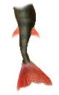

Other beings may exist (werewolves, yeti and similar, as you wish) but their existence must be an integral part of your story. In such a case, some evolution path for them should be described. They can be there instead of humans as well. Try to avoid mermaids, as water normally is low on oxygen and cannot sustain high-energy requirements of the developed brain.

Step 3: Development/divinations and The End.
How will your universe develop? Will you program the end according to some apocalyptic scenario? Ragnarok? Some myth that the sentient beings in your world believe the universe will end according to? Alternatively, is it open-ended? May be, it shalt exist forever?

Step 4: Writing the report
After you put together the pieces, start writing the report. It is best if you can draw some figures, diagrams, sketches to illustrate your narration and include them within the same file as the report. Best of luck with your assignment!

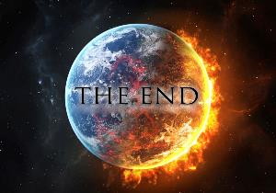

Use footnotes like this one (In MS Word, References - > insert footnote).

